RTD
# Source: AI Source: Provided by: [Data Path: Persons Table -> ID Column: 1, Name_En Column: Motasem Essam] -> From: [ChatGPT] on [7/17/2026]
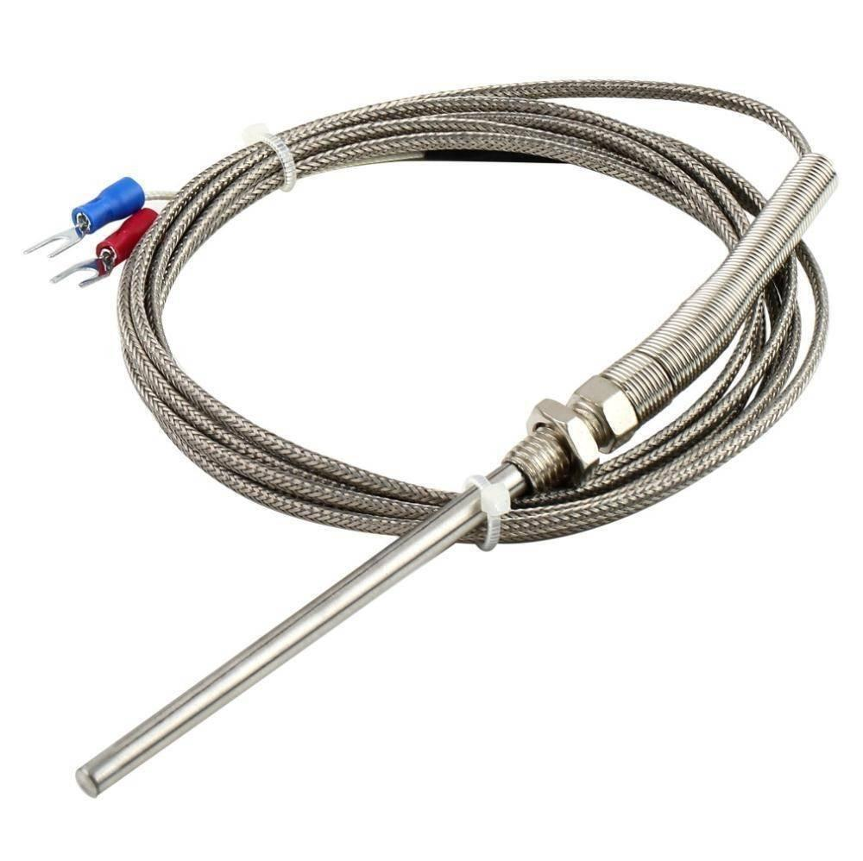
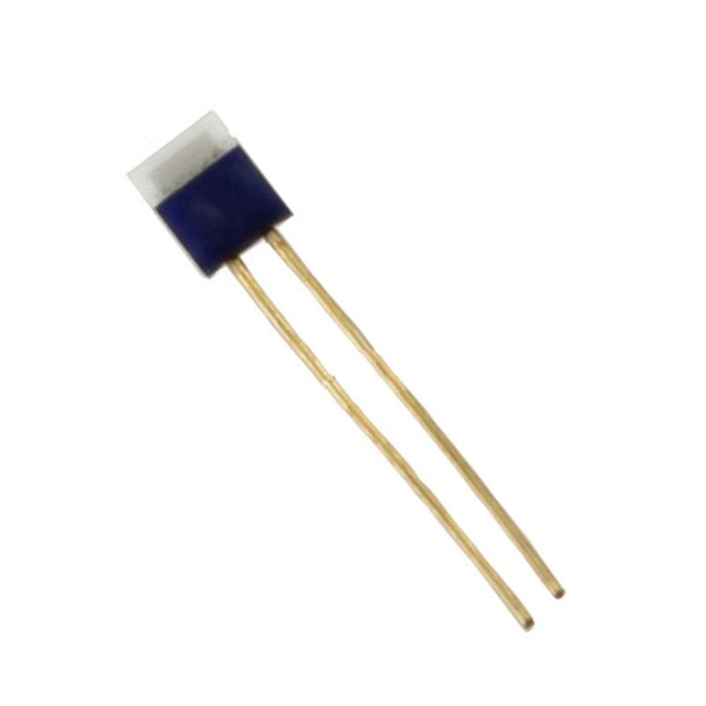

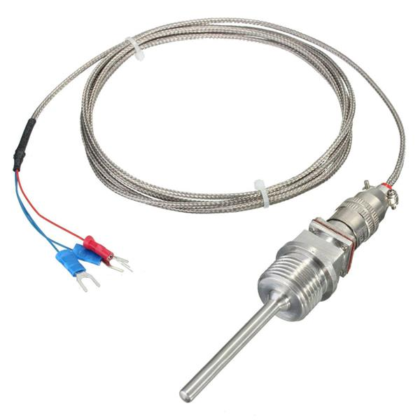
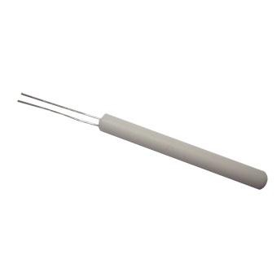
A Resistance Temperature Detector (RTD) is a highly accurate temperature sensor that measures temperature by detecting changes in the electrical resistance of a metal element, usually platinum. RTDs are widely used in industrial, laboratory, and scientific applications because of their excellent accuracy, repeatability, and long-term stability.

Definition
# Source: AI Source: Provided by: [Data Path: Persons Table -> ID Column: 1, Name_En Column: Motasem Essam] -> From: [ChatGPT] on [7/17/2026]
An RTD (Resistance Temperature Detector) is a temperature sensor whose electrical resistance changes predictably with temperature.

Purpose
# Source: AI Source: Provided by: [Data Path: Persons Table -> ID Column: 1, Name_En Column: Motasem Essam] -> From: [ChatGPT] on [7/17/2026]
An RTD is used to:
- Measure temperature accurately.
- Monitor industrial processes.
- Control heating and cooling systems.
- Calibrate laboratory equipment.
- Provide precise temperature feedback for automation systems.

Principle of Operation
# Source: AI Source: Provided by: [Data Path: Persons Table -> ID Column: 1, Name_En Column: Motasem Essam] -> From: [ChatGPT] on [7/17/2026]
An RTD operates on the principle that the electrical resistance of certain metals increases as temperature increases.
- Temperature rises → Resistance increases.
- Temperature falls → Resistance decreases.
The measuring instrument converts the resistance into a temperature reading.

Main Components
# Source: AI Source: Provided by: [Data Path: Persons Table -> ID Column: 1, Name_En Column: Motasem Essam] -> From: [ChatGPT] on [7/17/2026]
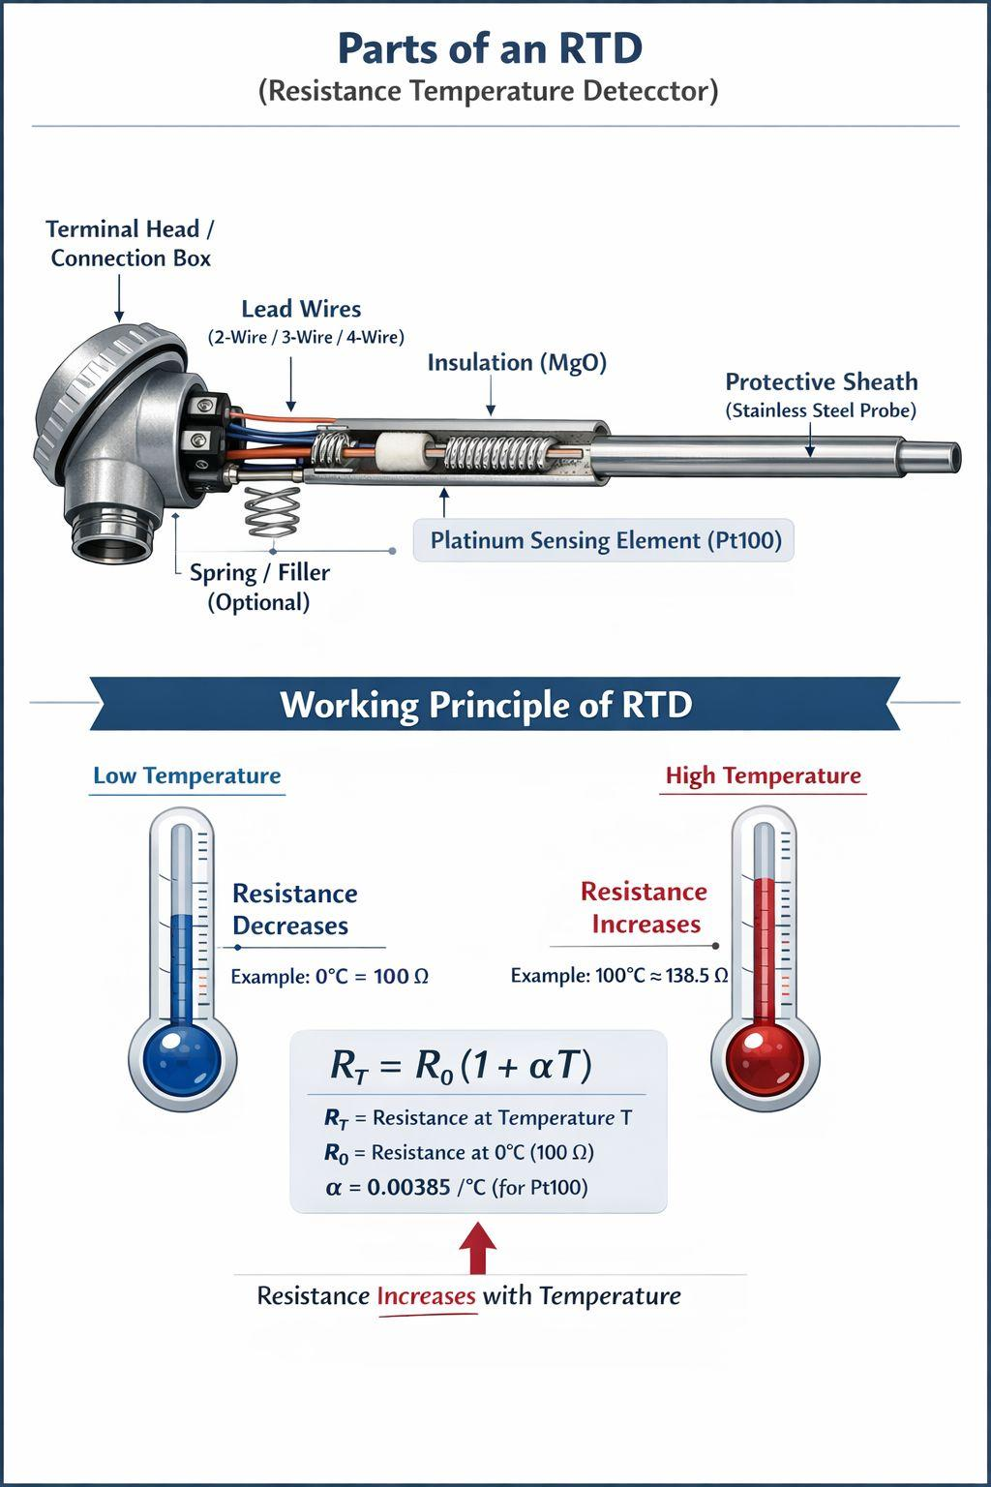
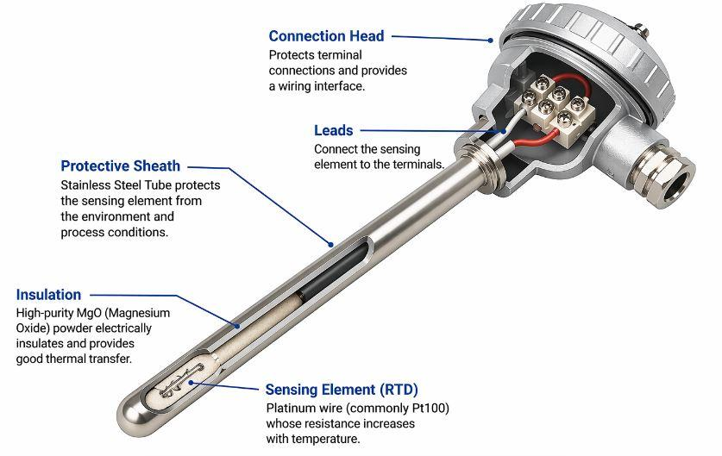
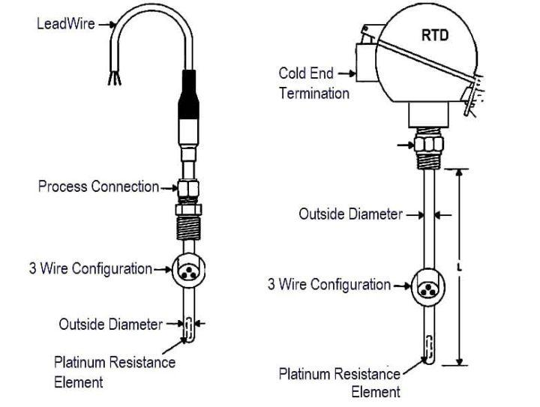
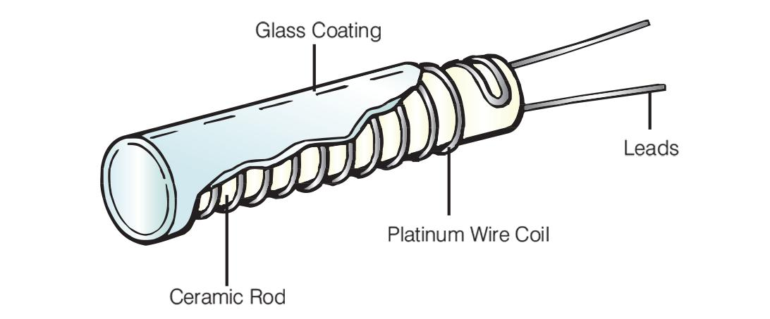
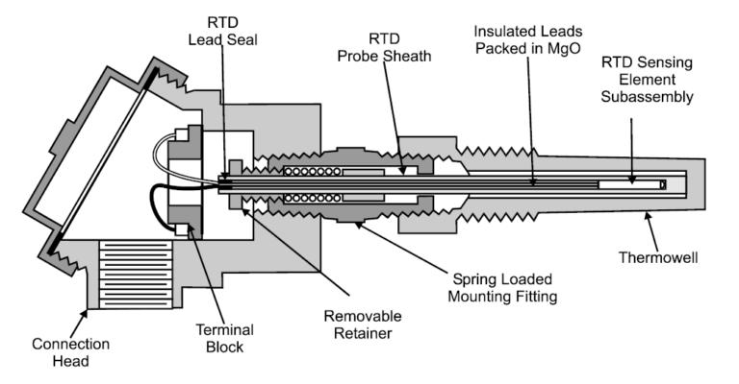
A typical RTD consists of:
- Platinum sensing element
- Protective sheath
- Lead wires (2-wire, 3-wire, or 4-wire)
- Insulating material
- Connection head or cable

Types of RTDs

1. Wire-Wound RTD
# Source: AI Source: Provided by: [Data Path: Persons Table -> ID Column: 1, Name_En Column: Motasem Essam] -> From: [ChatGPT] on [7/17/2026]
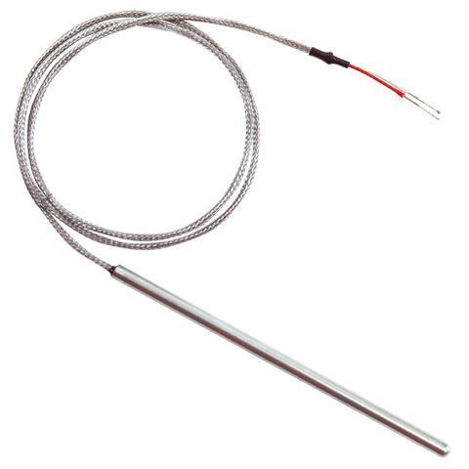
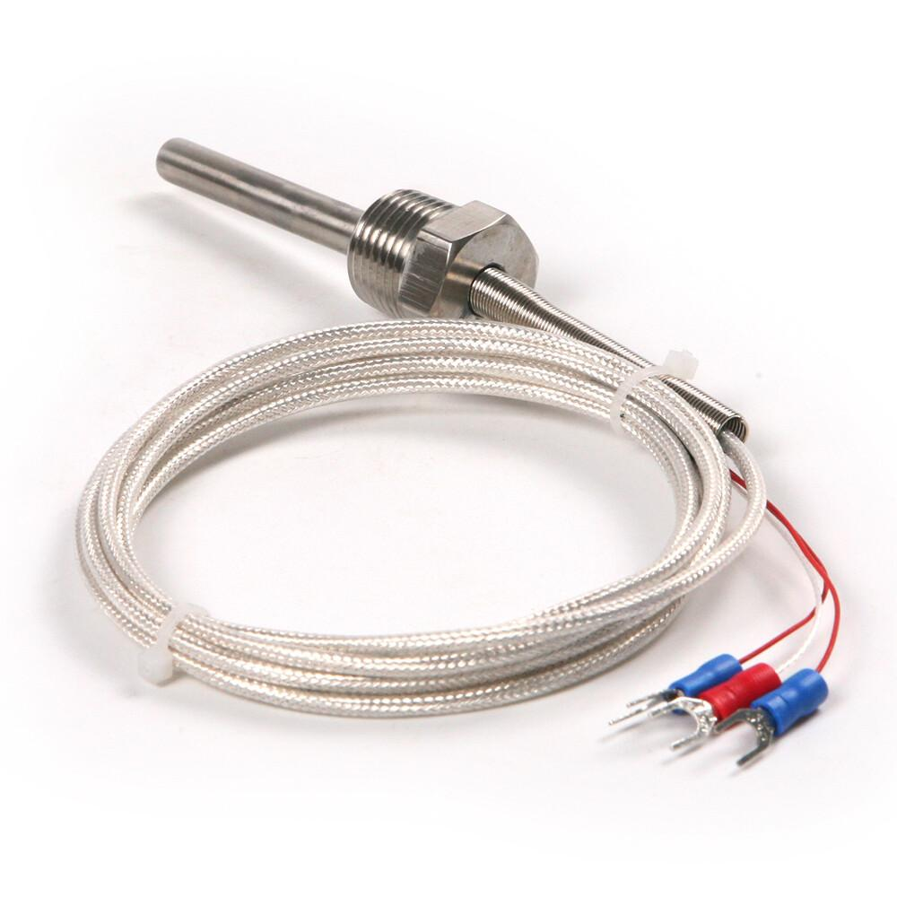
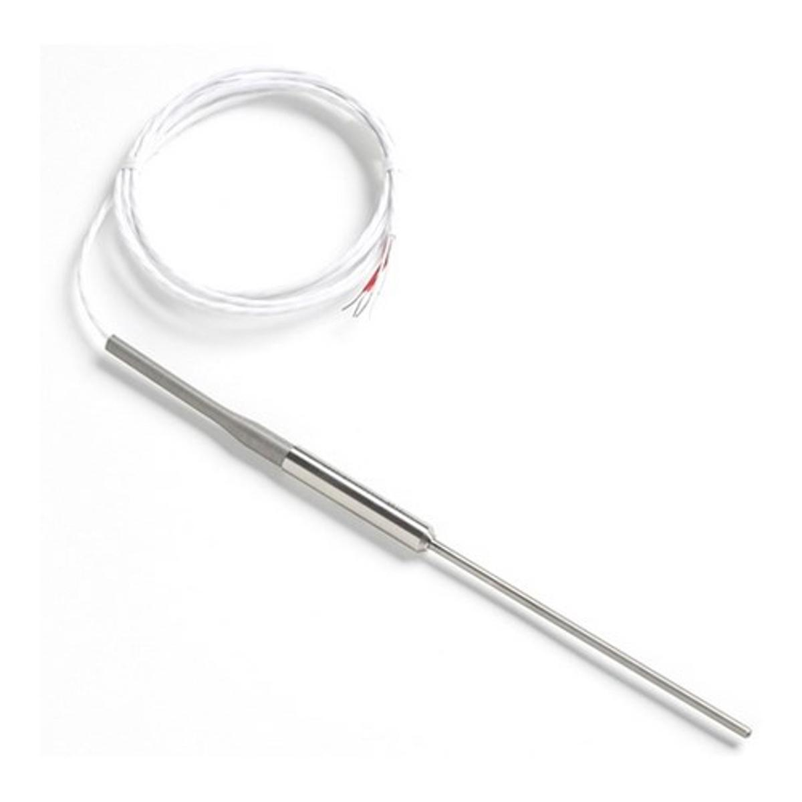
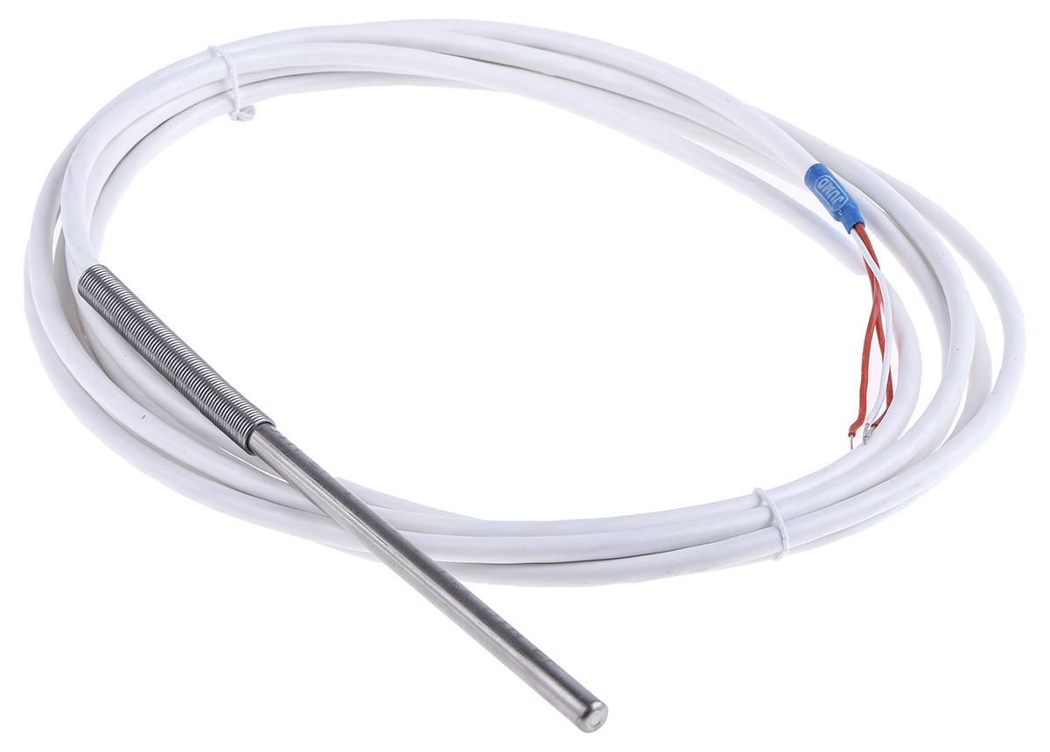
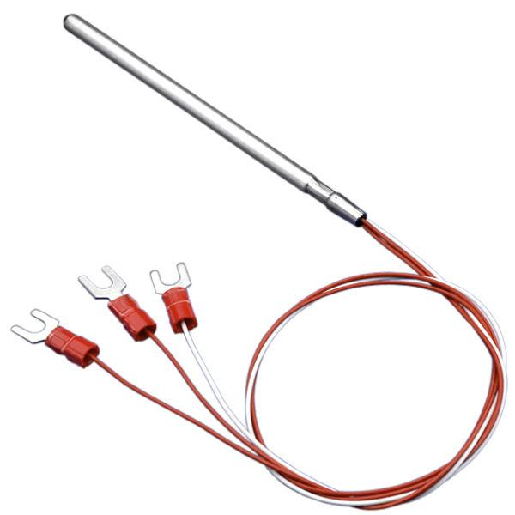
Description
A precision RTD made by winding a fine platinum wire around a ceramic or glass core.
Applications
- Calibration laboratories
- Scientific research
- Precision industrial measurement

2. Thin-Film RTD
# Source: AI Source: Provided by: [Data Path: Persons Table -> ID Column: 1, Name_En Column: Motasem Essam] -> From: [ChatGPT] on [7/17/2026]
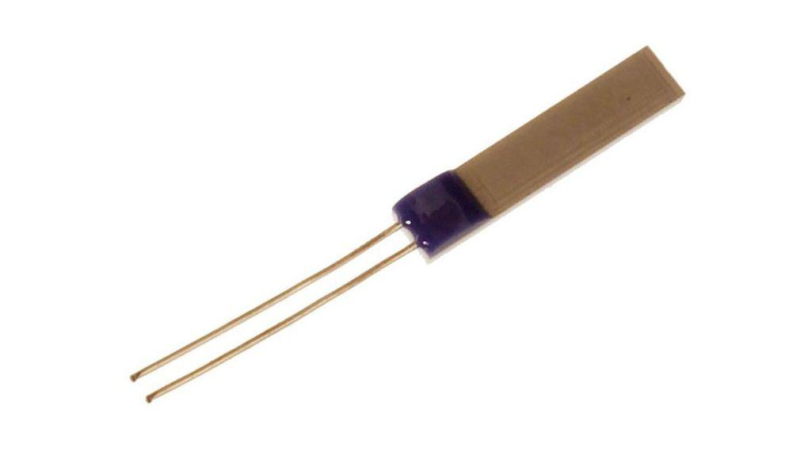
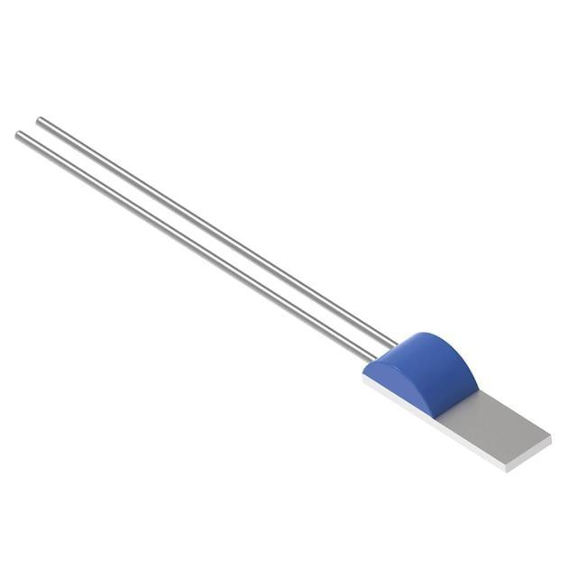
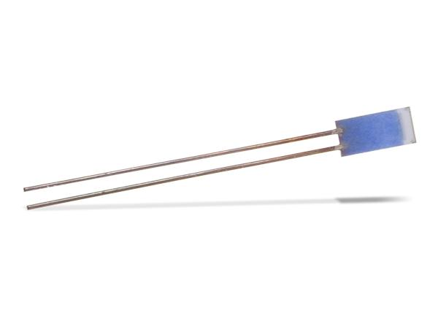
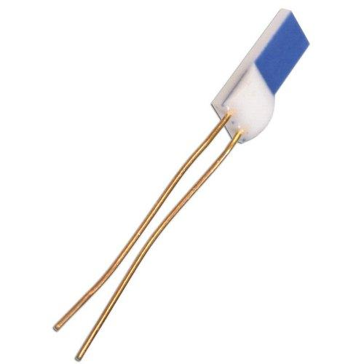
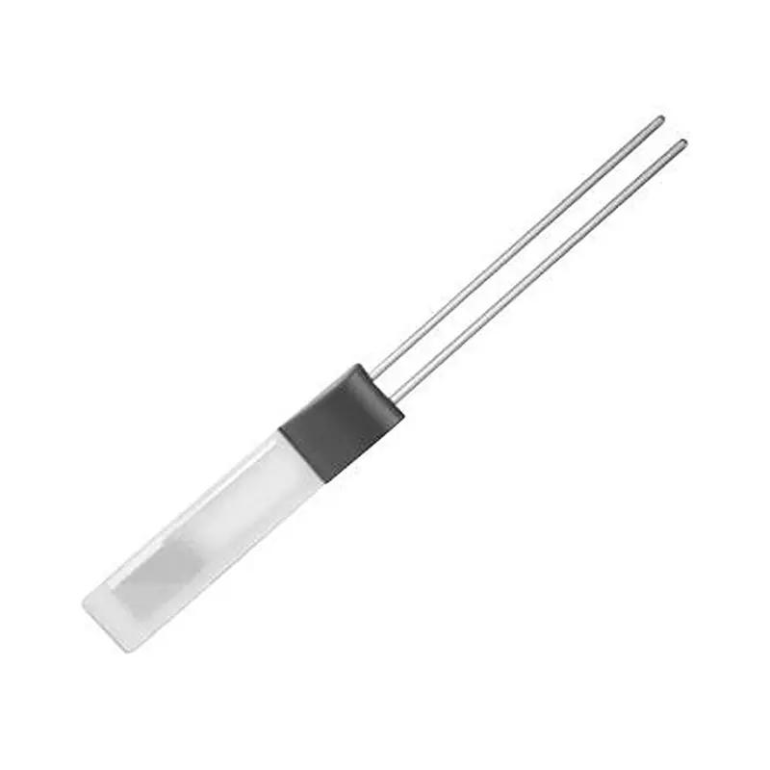
Description
A compact RTD with a thin platinum film deposited on a ceramic substrate.
Applications
- Industrial automation
- HVAC systems
- Medical equipment
- Food processing

3. Probe RTD
# Source: AI Source: Provided by: [Data Path: Persons Table -> ID Column: 1, Name_En Column: Motasem Essam] -> From: [ChatGPT] on [7/17/2026]
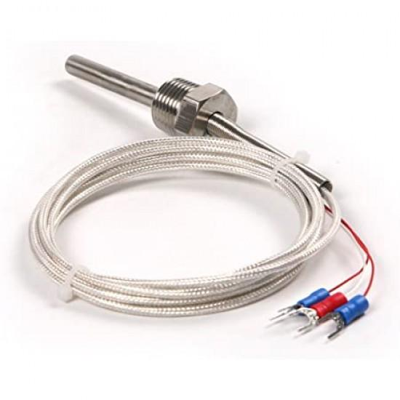
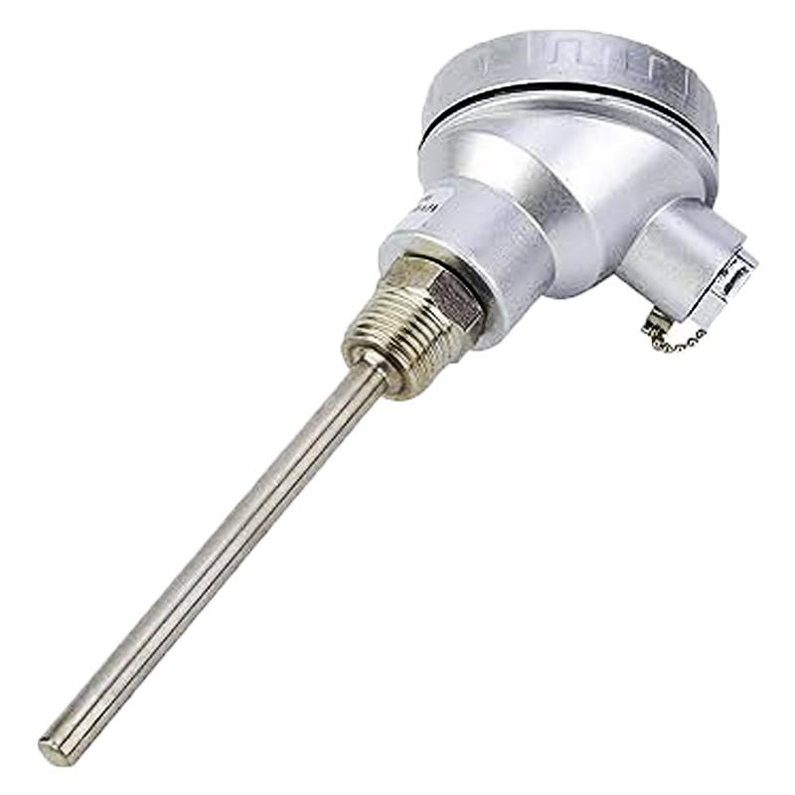
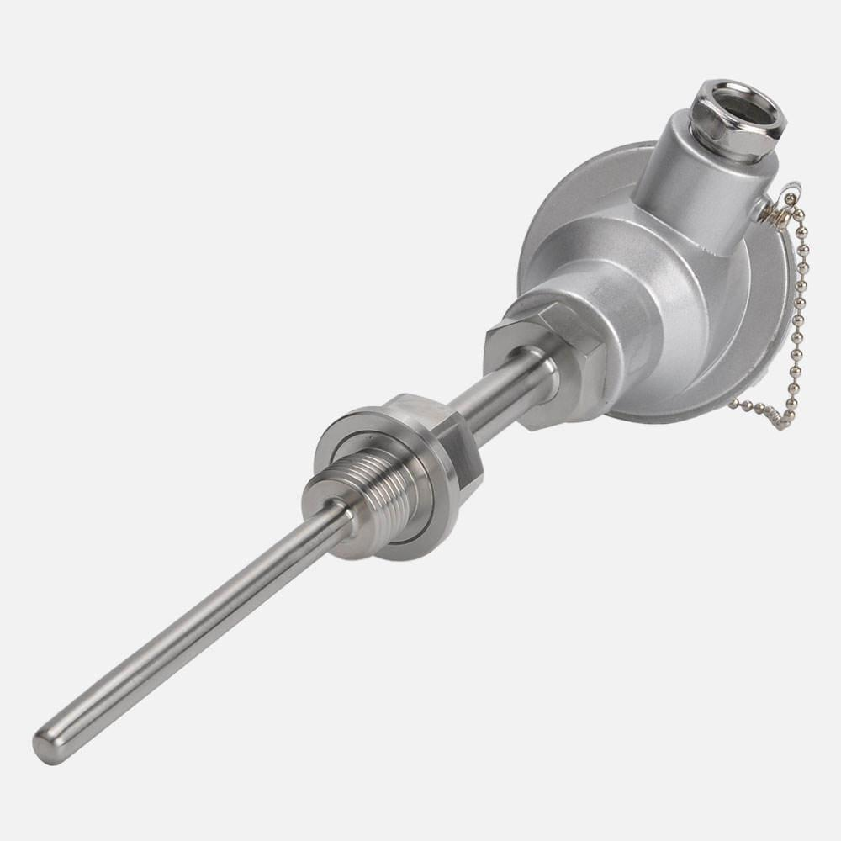
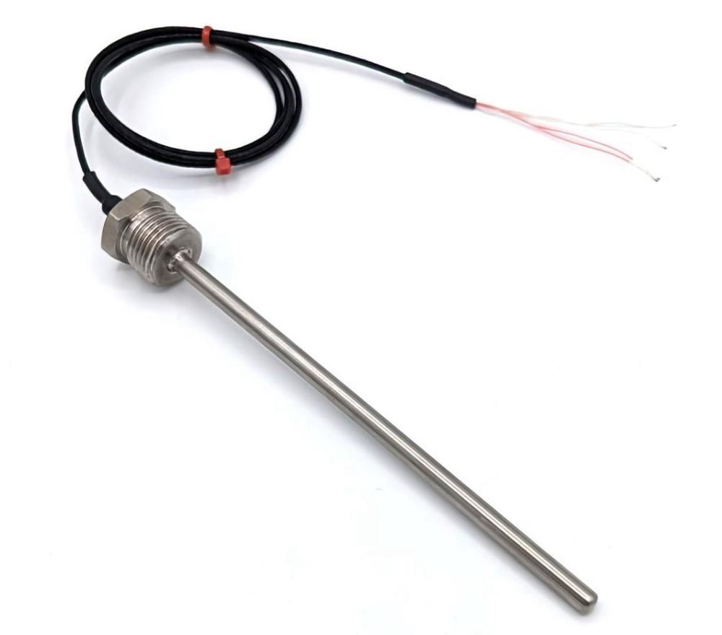
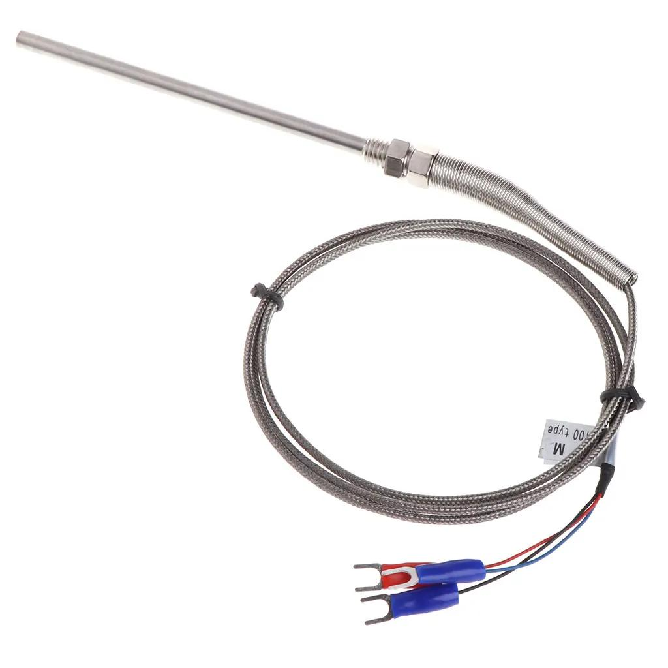
Description
An RTD sensing element enclosed in a protective stainless-steel probe for measuring the temperature of liquids, gases, or process equipment.
Applications
- Industrial process control
- Chemical plants
- Food industry
- Laboratories

4. Surface-Mount RTD
# Source: AI Source: Provided by: [Data Path: Persons Table -> ID Column: 1, Name_En Column: Motasem Essam] -> From: [ChatGPT] on [7/17/2026]
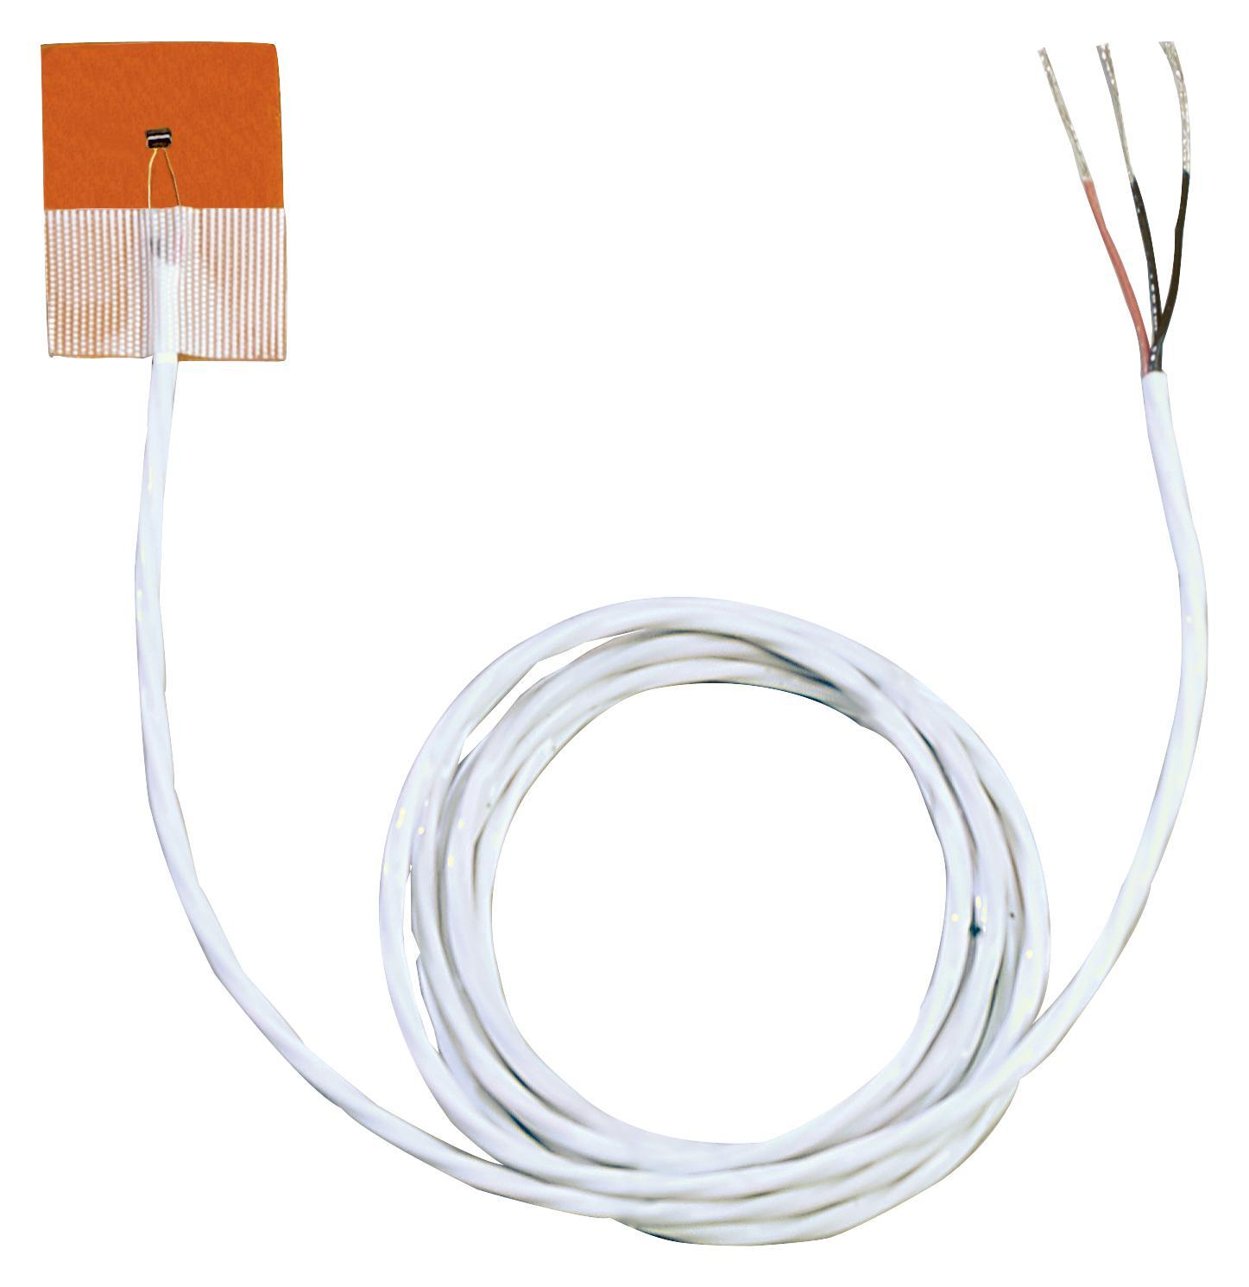
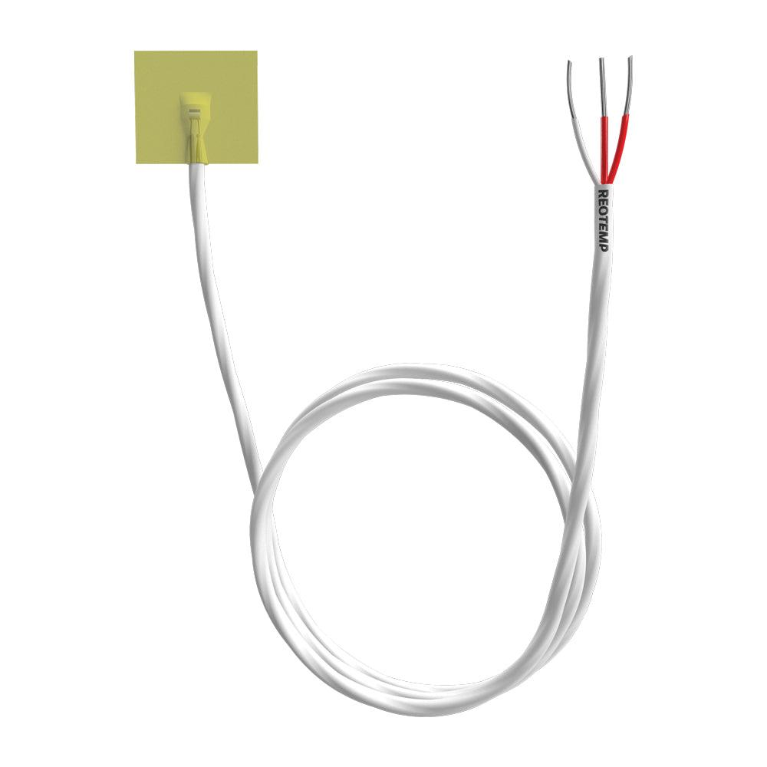
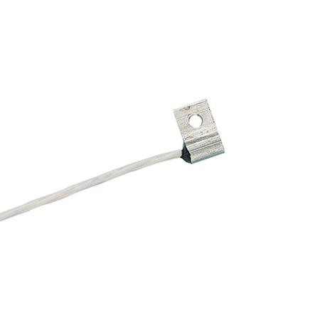
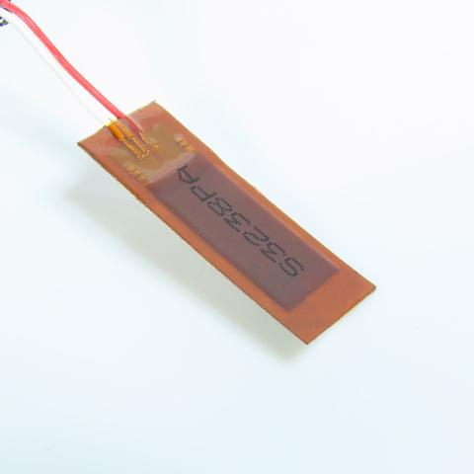
Description
An RTD designed to be attached directly to a solid surface for measuring surface temperature.
Applications
- Pipes
- Heat exchangers
- Motors
- Machinery
- Industrial equipment

Common RTD Standards
# Source: AI Source: Provided by: [Data Path: Persons Table -> ID Column: 1, Name_En Column: Motasem Essam] -> From: [ChatGPT] on [7/17/2026]
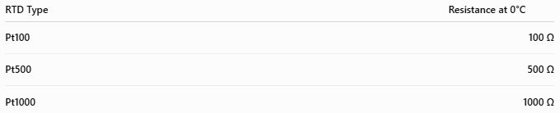
RTD Type | Resistance at 0°C
Pt100 | 100 Ω
Pt500 | 500 Ω
Pt1000 | 1000 Ω

Measuring Units
# Source: AI Source: Provided by: [Data Path: Persons Table -> ID Column: 1, Name_En Column: Motasem Essam] -> From: [ChatGPT] on [7/17/2026]
RTDs measure temperature in:
- Degree Celsius (°C)
- Kelvin (K)
- Degree Fahrenheit (°F)

Measuring Range
# Source: AI Source: Provided by: [Data Path: Persons Table -> ID Column: 1, Name_En Column: Motasem Essam] -> From: [ChatGPT] on [7/17/2026]
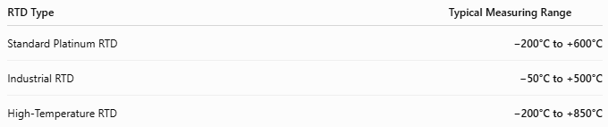
RTD Type | Typical Measuring Range
Standard Platinum RTD | −200°C to +600°C
Industrial RTD | −50°C to +500°C
High-Temperature RTD | −200°C to +850°C

Resolution
# Source: AI Source: Provided by: [Data Path: Persons Table -> ID Column: 1, Name_En Column: Motasem Essam] -> From: [ChatGPT] on [7/17/2026]
Resolution depends on the measuring electronics.
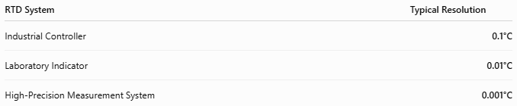
RTD System | Typical Resolution
Industrial Controller | 0.1°C
Laboratory Indicator | 0.01°C
High-Precision Measurement System | 0.001°C

Accuracy
# Source: AI Source: Provided by: [Data Path: Persons Table -> ID Column: 1, Name_En Column: Motasem Essam] -> From: [ChatGPT] on [7/17/2026]
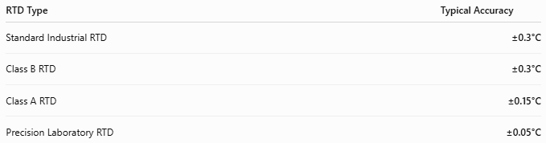
RTD Type | Typical Accuracy
Standard Industrial RTD | ±0.3°C
Class B RTD | ±0.3°C
Class A RTD | ±0.15°C
Precision Laboratory RTD | ±0.05°C
Notes
- Class A RTDs are more accurate than Class B.
- Platinum RTDs offer excellent long-term stability and high repeatability.
- Accuracy depends on calibration, wiring configuration (2-, 3-, or 4-wire), and measurement electronics.

How to Use an RTD
# Source: AI Source: Provided by: [Data Path: Persons Table -> ID Column: 1, Name_En Column: Motasem Essam] -> From: [ChatGPT] on [7/17/2026]
- Connect the RTD to the measuring instrument.
- Place the sensing probe in contact with the object or medium.
- Allow the reading to stabilize.
- Read the temperature on the display.

Applications
# Source: AI Source: Provided by: [Data Path: Persons Table -> ID Column: 1, Name_En Column: Motasem Essam] -> From: [ChatGPT] on [7/17/2026]
RTDs are used in:
- Industrial process control
- Chemical plants
- Power generation
- Pharmaceutical manufacturing
- Food processing
- Scientific laboratories
- HVAC systems
- Medical equipment

Advantages
# Source: AI Source: Provided by: [Data Path: Persons Table -> ID Column: 1, Name_En Column: Motasem Essam] -> From: [ChatGPT] on [7/17/2026]
An RTD:
- Provides very high accuracy.
- Has excellent long-term stability.
- Offers high repeatability.
- Covers a wide temperature range.
- Produces reliable measurements over many years.

Limitations
# Source: AI Source: Provided by: [Data Path: Persons Table -> ID Column: 1, Name_En Column: Motasem Essam] -> From: [ChatGPT] on [7/17/2026]
An RTD:
- Is more expensive than thermistors.
- Responds more slowly than thermocouples.
- Requires excitation current.
- Can be affected by lead-wire resistance (unless compensated with 3- or 4-wire connections).

Sources of Error
# Source: AI Source: Provided by: [Data Path: Persons Table -> ID Column: 1, Name_En Column: Motasem Essam] -> From: [ChatGPT] on [7/17/2026]
Sensor Errors
- Calibration drift
- Mechanical damage
- Aging

User Errors
- Incorrect wiring
- Poor installation
- Insufficient stabilization time

Environmental Errors
- Electrical interference
- Moisture
- Thermal gradients
- Lead-wire resistance (especially with 2-wire RTDs)

Comparison with Other Temperature Sensors
# Source: AI Source: Provided by: [Data Path: Persons Table -> ID Column: 1, Name_En Column: Motasem Essam] -> From: [ChatGPT] on [7/17/2026]
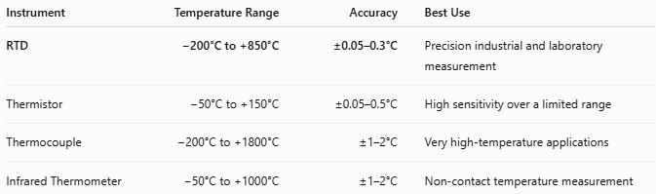
Instrument | Temperature Range | Accuracy | Best Use
RTD | −200°C to +850°C | ±0.05–0.3°C | Precision industrial and laboratory measurement
Thermistor | −50°C to +150°C | ±0.05–0.5°C | High sensitivity over a limited range
Thermocouple | −200°C to +1800°C | ±1–2°C | Very high-temperature applications
Infrared Thermometer | −50°C to +1000°C | ±1–2°C | Non-contact temperature measurement

Care and Maintenance
# Source: AI Source: Provided by: [Data Path: Persons Table -> ID Column: 1, Name_En Column: Motasem Essam] -> From: [ChatGPT] on [7/17/2026]
To maintain accuracy:
- Protect the sensing element from mechanical shock.
- Keep electrical connections clean.
- Avoid moisture entering the probe.
- Calibrate periodically.
- Use the appropriate wiring configuration for precision applications.

Common Mistakes
# Source: AI Source: Provided by: [Data Path: Persons Table -> ID Column: 1, Name_En Column: Motasem Essam] -> From: [ChatGPT] on [7/17/2026]
- Using a 2-wire RTD when high accuracy is required.
- Poor thermal contact with the measured object.
- Ignoring lead-wire resistance.
- Operating beyond the specified temperature range.

Key Points
# Source: AI Source: Provided by: [Data Path: Persons Table -> ID Column: 1, Name_En Column: Motasem Essam] -> From: [ChatGPT] on [7/17/2026]
- RTD stands for Resistance Temperature Detector.
- It measures temperature by detecting changes in electrical resistance.
- The sensing element is usually platinum.
- Common RTD types:
  - Wire-Wound RTD
  - Thin-Film RTD
  - Probe RTD
  - Surface-Mount RTD
- Common standards:
  - Pt100
  - Pt500
  - Pt1000

Conclusion
# Source: AI Source: Provided by: [Data Path: Persons Table -> ID Column: 1, Name_En Column: Motasem Essam] -> From: [ChatGPT] on [7/17/2026]
An RTD (Resistance Temperature Detector) is one of the most accurate and stable temperature sensors available. By measuring predictable changes in the electrical resistance of a platinum element, RTDs provide reliable, repeatable, and highly precise temperature measurements across a wide temperature range. Their performance makes them indispensable in industrial automation, scientific research, calibration laboratories, pharmaceutical manufacturing, power generation, and quality control.

